**USB/IP 사용법**

날짜 : 2012.02.16(금)

지도교수 : 이민석 교수님

|  |  |  |
| --- | --- | --- |
| Lemonade | 학번 | 이름 |
| 0592073 | 이상현(조장) |
| 0592051 | 김종욱 |
| 0792047 | 강인구 |
| 0792078 | 이윤재 |

**문서 정보 수정 내역**

|  |  |
| --- | --- |
| 파일명 | Usbip 사용법 |
| 원본 작성자 | 이상현, 김종욱, 강인구, 이윤재 |
| 수정자 | 이상현, 김종욱, 강인구, 이윤재 |

**버전 정보**

|  |  |  |  |  |
| --- | --- | --- | --- | --- |
| 날짜 | 수정자 | 버전 | 수정/추가 | 내용 |
| 2012.02.10(금) | 이상현 | 1.0 | 추가 |  |
|  |  |  |  |  |
|  |  |  |  |  |
|  |  |  |  |  |
|  |  |  |  |  |
|  |  |  |  |  |
|  |  |  |  |  |

**목차**

1. **설치하기**
   1. **Server**
   2. **Client**
2. **사용하기**
3. **설치하기**
   1. **Server**

서버 측은 리눅스 OS에서만 사용 가능합니다.

http://usbip.svn.sourceforge.net/viewvc/usbip/?view=tar 로 파일을 다운로드 한 후

압축을 풉니다.

터미널에서 ~\usbip\obsolete\linux\branches\usbipd 폴더로 이동해서 README를 열어서

Requirements에 있는 프로그램들을 설치합니다.

README 파일의 내용

서버 측은 리눅스 OS에서만 사용 가능합니다.

<http://usbip.svn.sourceforge.net/viewvc/usbip/?view=tar> 로 파일을 다운로드 한 후

압축을 풉니다.

터미널에서 ~\usbip\obsolete\linux\branches\usbipd 폴더로 이동해서 README를 열어서

Requirements에 있는 프로그램들을 설치합니다.

README 파일의 내용

|  |
| --- |
| # vim:tw=78:ts=4:expandtab:ai:sw=4  #  # README for usbip-utils  #  # Copyright (C) 2005-2008 Takahiro Hirofuchi  [Requirements]  - USB/IP device drivers  Its source code is included under $(top)/drivers/.  - sysfsutils >= 2.0.0  sysfsutils library  - libwrap0-dev  tcp wrapper library  - gcc >= 4.0  - libglib2.0-dev >= 2.6.0  - libtool, automake >= 1.9, autoconf >= 2.5.0, pkg-config  [Install]  0. Skip here if you see a configure script.  $ ./autogen.sh  1. Compile & install.  $ ./configure  $ make install  2. Compile & install USB/IP drivers if not yet.  [Usage]  server:# (Attach your USB device physically.)  server:# insmod usbip_common_mod.ko  server:# insmod usbip.ko  - It was formerly named as stub.ko.  server:# usbipd -D  - Start usbip daemon.  server:# usbip_bind_driver --list  - List driver assignments for usb devices.  server:# usbip_bind_driver --usbip 1-2  - Bind usbip.ko to the device of busid 1-2.  - A usb device 1-2 is now exportable to other hosts!  - Use 'usbip_bind_driver --other 1-2' when you want to shutdown exporting  and use the device locally.  client:# insmod usbip_common_mod.ko  client:# insmod vhci-hcd.ko  - It was formerly named as vhci.ko.  client:# usbip --list server  - List exportable usb devices on the server.  client:# usbip --attach server 1-2  - Connect the remote USB device.  client:# usbip --port  - Show virtual port status.  client:# usbip --detach 0  - Detach the usb device.  [Output Example]  --------------------------------------------------------------------------------------------------------  - SERVER SIDE (physically attach your USB devices to this host) ----------------------------------------  --------------------------------------------------------------------------------------------------------  trois:# insmod (somewhere)/usbip_common_mod.ko  trois:# insmod (somewhere)/usbip.ko  trois:# usbipd -D  --------------------------------------------------------------------------------------------------------  In another terminal, let's look up what usb devices are physically attached to  this host. We can see a usb storage device of busid 3-3.2 is now bound to  usb-storage driver. To export this device, we first mark the device as  "exportable"; the device is bound to usbip driver. Please remember you can not  export a usb hub.  trois:# usbip_bind_driver --list  List USB devices  - busid 3-3.2 (04bb:0206)  3-3.2:1.0 -> usb-storage    - busid 3-3.1 (08bb:2702)  3-3.1:1.0 -> snd-usb-audio  3-3.1:1.1 -> snd-usb-audio    - busid 3-3 (0409:0058)  3-3:1.0 -> hub    - busid 3-2 (0711:0902)  3-2:1.0 -> none    - busid 1-1 (05a9:a511)  1-1:1.0 -> ov511    - busid 4-1 (046d:08b2)  4-1:1.0 -> none  4-1:1.1 -> none  4-1:1.2 -> none    - busid 5-2 (058f:9254)  5-2:1.0 -> hub    --------------------------------------------------------------------------------------------------------  Mark the device of busid 3-3.2 as exportable.  trois:# usbip_bind_driver --usbip 3-3.2  ** (process:24621): DEBUG: 3-3.2:1.0 -> none  ** (process:24621): DEBUG: write "add 3-3.2" to /sys/bus/usb/drivers/usbip/match_busid  ** Message: bind 3-3.2 to usbip, complete!    trois:# usbip_bind_driver --list  List USB devices  - busid 3-3.2 (04bb:0206)  3-3.2:1.0 -> usbip  (snip)  Iterate the above operation for other devices if you like.  --------------------------------------------------------------------------------------------------------  - CLIENT SIDE ------------------------------------------------------------------------------------------  --------------------------------------------------------------------------------------------------------  First, let's list available remote devices which are marked as exportable in  the server host.  deux:# insmod (somewhere)/usbip_common_mod.ko  deux:# insmod (somewhere)/vhci_hcd.ko  deux:# usbip --list 10.0.0.3  - 10.0.0.3  1-1: Prolific Technology, Inc. : unknown product (067b:3507)  : /sys/devices/pci0000:00/0000:00:1f.2/usb1/1-1  : (Defined at Interface level) / unknown subclass / unknown protocol (00/00/00)  : 0 - Mass Storage / SCSI / Bulk (Zip) (08/06/50)    1-2.2.1: Apple Computer, Inc. : unknown product (05ac:0203)  : /sys/devices/pci0000:00/0000:00:1f.2/usb1/1-2/1-2.2/1-2.2.1  : (Defined at Interface level) / unknown subclass / unknown protocol (00/00/00)  : 0 - Human Interface Devices / Boot Interface Subclass / Keyboard (03/01/01)    1-2.2.3: OmniVision Technologies, Inc. : OV511+ WebCam (05a9:a511)  : /sys/devices/pci0000:00/0000:00:1f.2/usb1/1-2/1-2.2/1-2.2.3  : (Defined at Interface level) / unknown subclass / unknown protocol (00/00/00)  : 0 - Vendor Specific Class / unknown subclass / unknown protocol (ff/00/00)    3-1: Logitech, Inc. : QuickCam Pro 4000 (046d:08b2)  : /sys/devices/pci0000:00/0000:00:1e.0/0000:02:0a.0/usb3/3-1  : (Defined at Interface level) / unknown subclass / unknown protocol (00/00/00)  : 0 - Data / unknown subclass / unknown protocol (0a/ff/00)  : 1 - Audio / Control Device / unknown protocol (01/01/00)  : 2 - Audio / Streaming / unknown protocol (01/02/00)    4-1: Logitech, Inc. : QuickCam Express (046d:0870)  : /sys/devices/pci0000:00/0000:00:1e.0/0000:02:0a.1/usb4/4-1  : Vendor Specific Class / Vendor Specific Subclass / Vendor Specific Protocol (ff/ff/ff)  : 0 - Vendor Specific Class / Vendor Specific Subclass / Vendor Specific Protocol (ff/ff/ff)    4-2: Texas Instruments Japan : unknown product (08bb:2702)  : /sys/devices/pci0000:00/0000:00:1e.0/0000:02:0a.1/usb4/4-2  : (Defined at Interface level) / unknown subclass / unknown protocol (00/00/00)  : 0 - Audio / Control Device / unknown protocol (01/01/00)  : 1 - Audio / Streaming / unknown protocol (01/02/00)    --------------------------------------------------------------------------------------------------------  Attach a remote usb device!  deux:# usbip --attach 10.0.0.3 1-1  port 0 attached    --------------------------------------------------------------------------------------------------------  Show what devices are attached to this client.  deux:# usbip --port  Port 00: <Port in Use> at Full Speed(12Mbps)  Prolific Technology, Inc. : unknown product (067b:3507)  6-1 -> usbip://10.0.0.3:3240/1-1 (remote bus/dev 001/004)  6-1:1.0 used by usb-storage  /sys/class/scsi_device/0:0:0:0/device  /sys/class/scsi_host/host0/device  /sys/block/sda/device    --------------------------------------------------------------------------------------------------------  Detach the imported device.  deux:# usbip --detach 0  port 0 detached    --------------------------------------------------------------------------------------------------------  [Check List]  - See Debug Tips in the project wiki.  - http://usbip.wiki.sourceforge.net/how-to-debug-usbip  - usbip.ko must be bound to the target device.  - See /proc/bus/usb/devices and find "Driver=..." lines of the device.  - Shutdown firewall.  - usbip now uses TCP port 3240.  - Disable SELinux.  - If possible, compile your kernel with CONFIG_USB_DEBUG flag and try  again.  - Check your kernel and daemon messages.  ex. /var/log/{messages, kern.log, daemon.log, syslog}  [Contact]  Mailing List: usbip-devel _at_ lists.sourceforge.net |

설치가 완료 되면, 터미널에

> sudo ./autogen.sh

> sudo ./configure

> sudo make

> sudo make install

을 차례대로 해줍니다.

만약 설치가 다 되었다면 ~\usbip\obsolete\linux\branches\usbipd\cmd 폴더에

Usbip, usbipd, usbip_bind_driver 파일이 생성됩니다.

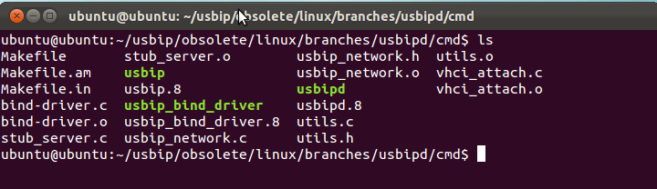

이제 리눅스에 USBIP 설치가 완료되었습니다.

* 1. **Client**

클라이언트 쪽은 리눅스와 윈도우가 가능한데, 리눅스에 대한 지식이 부족해 윈도우 쪽으로 해보겠습니다.

<http://sourceforge.net/projects/usbip/files/usbip_windows/usbip_windows_v0.2.0.0_signed.zip/download> 를 눌러서 다운을 받고 압축을 풉니다.

USAGE 파일을 열어서 드라이버를 설치합니다.

USAGE 파일의 내용

|  |
| --- |
| To install the virtual usb bus driver on Windows XP:  1. Uncompress the downloaded binary package to a directory.  2. Double-click the 'Add Hardware' wizard in Control Panel.  3. At the 'Welcome to the Add Hardware Wizard', click 'Next'.  4. Select 'Yes, I have already connected the hardware', then click Next.  5. Select 'Add a new hardware device' from the list, then click Next.  6. Select 'Install the hardware that I manually select from a list(Advanced)', and then click next.  7. Select 'System Devices', then click Next.  8. Click 'Have Disk', click 'Browse', choose the uncompressed directory, and click OK.  9. Click on the 'USB/IP Enumerator', and then click Next.  10. At 'The wizard is ready to install your hardware', click Next.  11. Click Finish at 'Completing the Add/Remove Hardware Wizard.'  For Window 7 :  1. (Only necessary for custom builds: For x64 allow unsigned drivers: Enter "bcdedit /set testsigning on" in an administrative cmd window)  2. Uncompress the downloaded binary package to a directory.  3. Start a the Device Manager  4. Click Any hardware node  5. Choose "Add Legacy Hardware" from the "Action" menu  6. At the 'Welcome to the Add Hardware Wizard', click 'Next'.  7. Select 'Install the hardware that I manually select from the list'  8. click 'Next'  9. Click 'Have Disk', click 'Browse', choose the uncompressed directory, and click OK.  10. Click on the 'USB/IP Enumerator', and then click Next.  11. At 'The wizard is ready to install your hardware', click Next.  12. Click Finish at 'Completing the Add/Remove Hardware Wizard.'  To use it:  1. open a command prompt window, cd to the uncompressed directory.  2. run usbip -l 192.168.2.1 to list the exported devices from ip 192.168.2.1  3. run usbip -a 192.168.2.1 2-1 to imported the device.  (Of course, you should change 192.168.2.1 and 2-1 to something else) |

1. **사용하기**

서버 쪽에 USB를 연결합니다.

터미널에서 ~\usbip\obsolete\linux\branches\usbipd\cmd\ 이동하고,

> sudo ./usbipd 를 입력합니다.

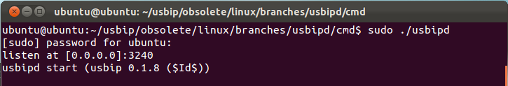

다른 터미널을 실행시켜서 다시 ~\usbip\obsolete\linux\branches\usbipd\cmd 폴더로 이동합니다.

> sudo ./usbip_bind_dirver -–list 를 입력하여 현재 연결된 장치들의 목록을 확인합니다.

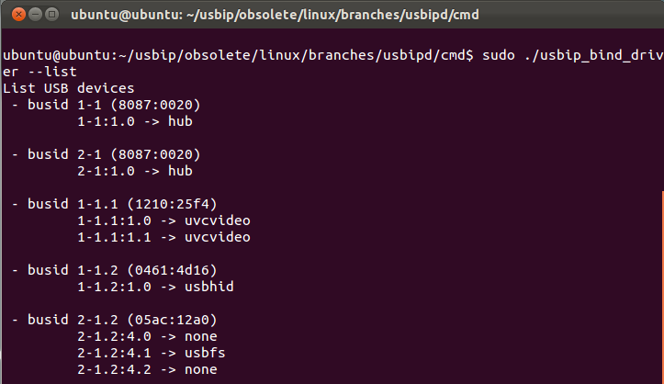

> sudo ./usbip_bind_driver –usbip busid(연결할 bus id)를 입력해서 장치를 연결합니다.

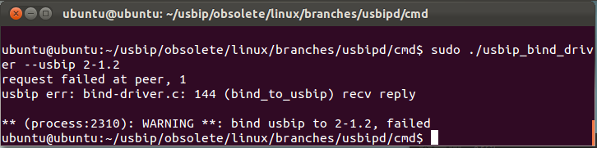

장치의 연결 시 위 사진과 같은 이미지가 출력되면,

> sudo mount –bind /dev/bus /proc/bus 를 입력합니다.

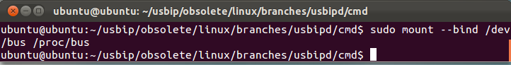

성공적으로 장치가 연결될 경우엔 아래와 같은 메시지가 출력 됩니다.

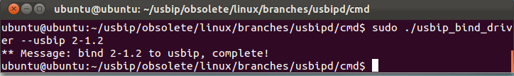

장치의 연결이 성공하면 클라이언트 쪽에서(USB가 연결될 PC) cmd를 실행시켜 usbip 압축 해제한 폴더로 이동합니다.

> usbip –l ip_address 를 입력해서 장치들의 목록을 확인합니다.

> usbip –a ip_address busid 를 입력해서 장치를 연결합니다.

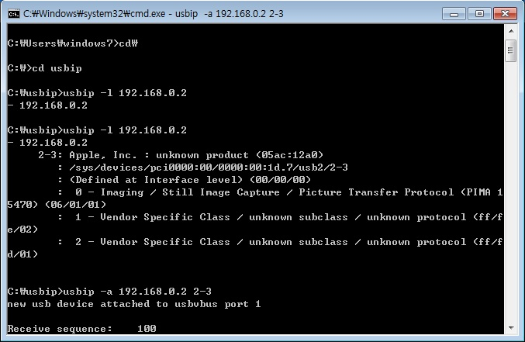

장치 연결이 성공돼서 클라이언트 PC에서 장치를 인식하는 모습입니다.

